**DAILY ONLINE ACTIVITIES SUMMARY**

|  |  |  |  |  |  |  |  |  |
| --- | --- | --- | --- | --- | --- | --- | --- | --- |
| **Date:** | **02/08/2020** | | | | | **Name:** | **RITIKA KULKARNI** | |
| **Sem & Sec** | **4th SEM. & ‘B’ SEC.** | | | | | **USN:** | **4AL19CS403** | |
| **Online Test Summary** | | | | | | | | |
| **Subject** | | **-----** | | | | | | |
| **Max. Marks** | | **--** | | **Score** | | | **--** | |
| **Certification Course Summary** | | | | | | | | |
| **Course** | **Fundamentals of computer hacking** | | | | | | | |
| **Certificate Provider** | | | **Udemy** | | **Duration** | | | **15 hrs** |
| **Coding Challenges** | | | | | | | | |
| **-----** | | | | | | | | |
| **Status : --** | | | | | | | | |
| **Uploaded the report in Github** | | | | | **Yes** | | | |
| **If yes Repository name** | | | | | **--** | | | |
| **Uploaded the report in slack** | | | | | **Yes** | | | |

**Online Test Summary: No internals conducted today.**

**Online Certification course Summary:In today's session, I select new certification course and today I learned about basic steganography and types of steganography .**

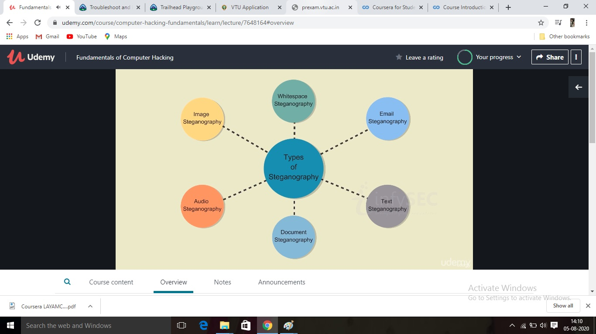

**Online Coding Summary: Today I didn’t receive the program.**